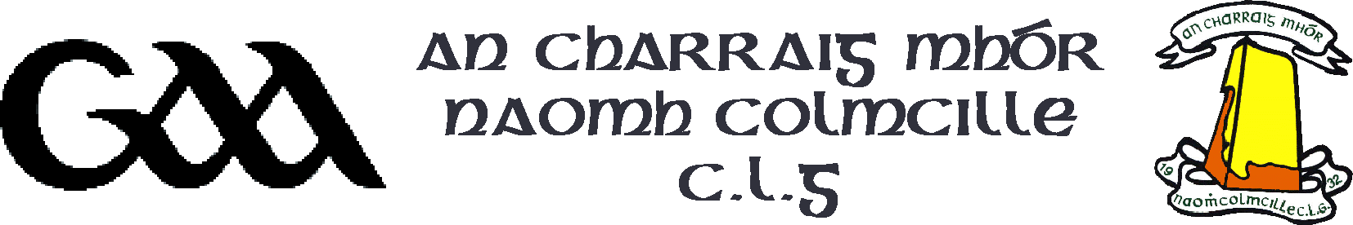

An Cathaoirleach: Padraig Mac Ailín
An Rúnaí: Póilín Ui Chuidithe Quarry Road
secretary.carrickmorestcolmcilles.tyrone@gaa.ie Carrickmore
Co. Tyrone BT79 9JX
10 Eanáir 2022

A chara,

Cruinniú Ginearálta Bliantúil - Annual General Meeting 2021
An Charraig Mhor Naomh Colmcille C.L.G. is holding its A.G.M. for 2021 on Dé Domhnaigh 30 Eanáir 2022 at 5pm in Dean Maguirc College. Please be mindful of current Covid19 restrictions and GAA guidelines if attending.

Please complete your nominations below adding motions/proposals to the back of this sheet. Members should sign and leave forms in the box provided in the Main Stand not later than 6pm on 20th November. All nominations/motions must be signed. Go raibh maith agat.

Is mise

Poilin Ui Chuidithe (An Rúnaí) (07899701201)
- - - - - - - - - - - - - - - - - - - - - - - - - - - - - - - - - - - - - - - - - - - - - - - - - - - - - - - - - -
Ainmniúcháin:-

An Cathaoirleach (Chairman) _____________________________________________________

An Leas-Cathaoirleach (Vice-Chairman) ___________________________________________

An Runai (Secretary) ______________________________________________________________

Leas Runai (Asst. Secretary) _______________________________________________________

Cisteoir (Treasurer) ________________________________________________________________

Leas Cisteoir (Asst. Treasurer) ______________________________________________________

Chairdreamh Poibil (P.R.O.) _________________________________________________________

Oifigeach Cultur (Language/Cultural Officer) _________________________________________

Coiste Contae (County Board Delegate) _______________________________________________

Ball den Choiste (Committee Members) Motions/Proposals overleaf please

__________________________ _____________________ _____________________

__________________________ _____________________ _____________________

__________________________ _____________________ _____________________

Síniú: __________________________ Dáta : _____________________

